1. Retrieve the total number of orders placed.

SELECT

COUNT(order_id) AS total_orders

FROM

orders;

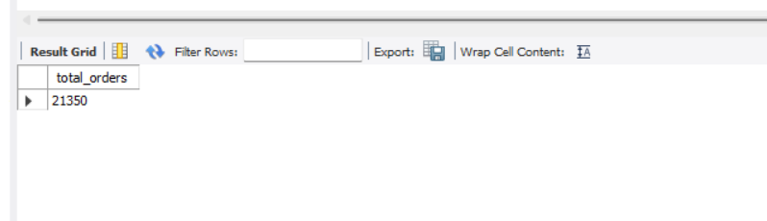

2. Calculate the total revenue generated from pizza sales.

SELECT

ROUND(SUM(order_details.quantity * pizzas.price), 2) AS total_sales

FROM

order_details

JOIN

pizzas ON pizzas.pizza_id = order_details.pizza_id

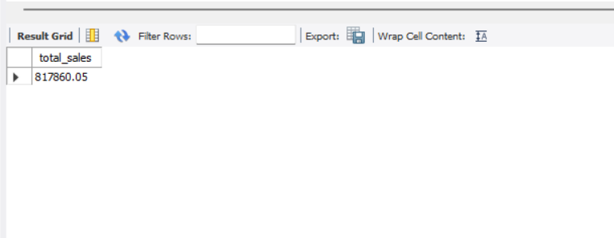

3. Identify the highest-priced pizza.

SELECT

pizza_types.name, pizzas.price

FROM

pizza_types

JOIN

pizzas ON pizza_types.pizza_type_id = pizzas.pizza_type_id

ORDER BY pizzas.price DESC

LIMIT 1;

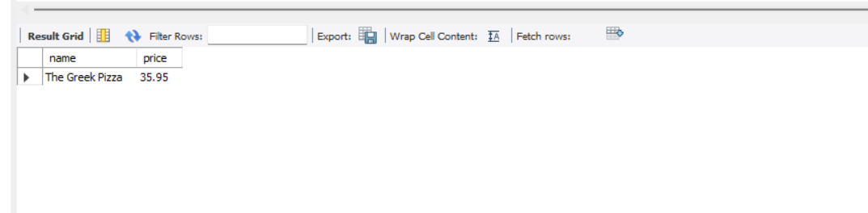

4. Identify the most common pizza size ordered.

SELECT

pizzas.size,

COUNT(order_details.order_details_id) AS order_count

FROM

pizzas

JOIN

order_details ON pizzas.pizza_id = order_details.pizza_id

GROUP BY pizzas.size

ORDER BY order_count DESC;

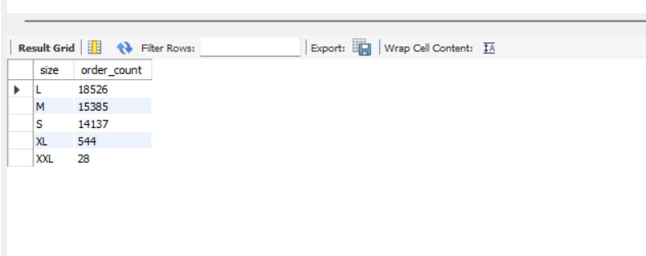

5. List the top 5 most ordered pizza types along with their quantities.

SELECT

pizza_types.name, SUM(order_details.quantity) AS quantity

FROM

pizza_types

JOIN

pizzas ON pizza_types.pizza_type_id = pizzas.pizza_type_id

JOIN

order_details ON order_details.pizza_id = pizzas.pizza_id

GROUP BY pizza_types.name

ORDER BY quantity DESC

LIMIT 5;

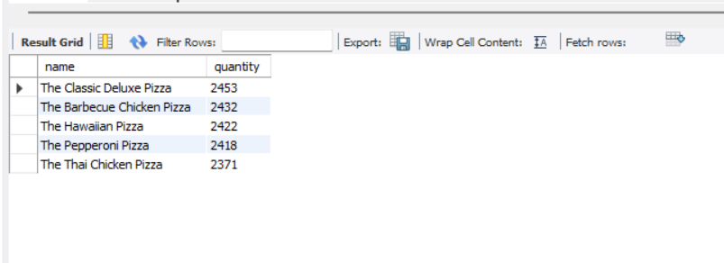

6. Join the necessary tables to find the total quantity of each pizza category ordered.

SELECT

pizza_types.category,

SUM(order_details.quantity) AS quantity

FROM

pizza_types

JOIN

pizzas ON pizza_types.pizza_type_id = pizzas.pizza_type_id

JOIN

order_details ON order_details.pizza_id = pizzas.pizza_id

GROUP BY pizza_types.category

ORDER BY quantity DESC;

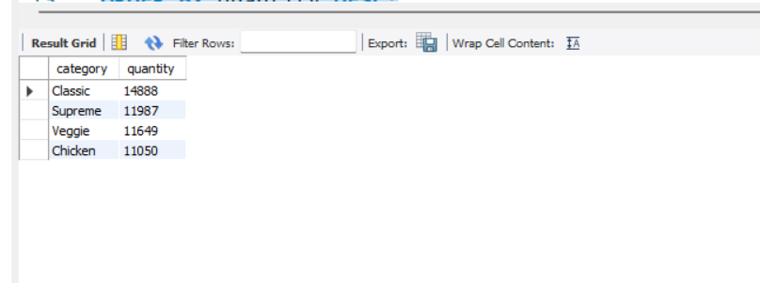

7. Determine the distribution of orders by hour of the day.

SELECT

HOUR(order_time) AS hour, COUNT(order_id) AS order_count

FROM

orders

GROUP BY HOUR(order_time);

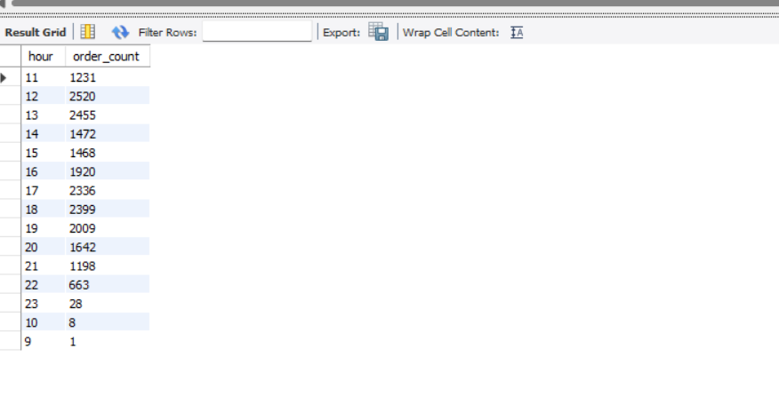

8. Join relevant tables to find the category-wise distribution of pizzas.

SELECT

category, COUNT(name)

FROM

pizza_types

GROUP BY category

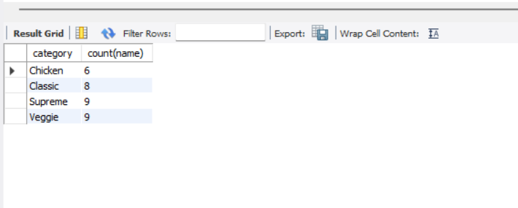

9. Group the orders by date and calculate the average number of pizzas ordered per day.

SELECT

ROUND(AVG(quantity), 0) as avg_pizza_ordered_per_day

FROM

(SELECT

orders.order_date, SUM(order_details.quantity) AS quantity

FROM

orders

JOIN order_details ON orders.order_id = order_details.order_id

GROUP BY orders.order_date) AS order_quantity;

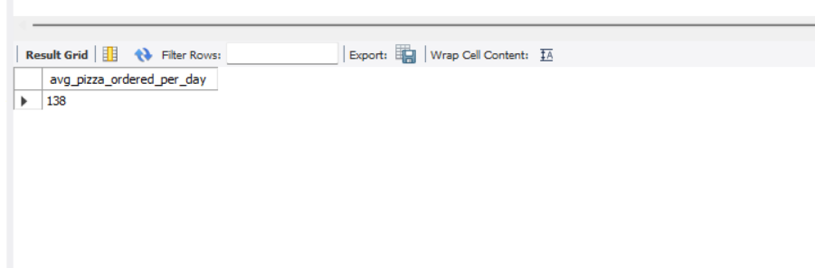

10. Determine the top 3 most ordered pizza types based on revenue.

SELECT

pizza_types.name,

SUM(order_details.quantity * pizzas.price) AS revenue

FROM

pizza_types

JOIN

pizzas ON pizzas.pizza_type_id = pizza_types.pizza_type_id

JOIN

order_details ON order_details.pizza_id = pizzas.pizza_id

GROUP BY pizza_types.name

ORDER BY revenue DESC

LIMIT 3;

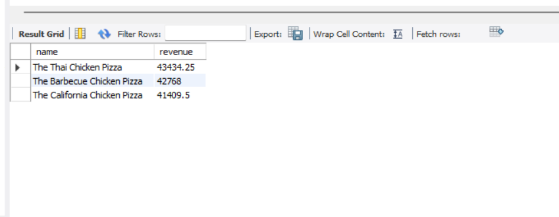

11. Calculate the percentage contribution of each pizza type to total revenue.

SELECT

pizza_types.category,

ROUND(SUM(order_details.quantity * pizzas.price) / (SELECT

ROUND(SUM(order_details.quantity * pizzas.price),

2) AS total_sales

FROM

order_details

JOIN

pizzas ON pizzas.pizza_id = order_details.pizza_id) * 100,

2) AS revenue

FROM pizza_types

JOIN

pizzas ON pizzas.pizza_type_id = pizza_types.pizza_type_id

JOIN

order_details ON order_details.pizza_id = pizzas.pizza_id

GROUP BY pizza_types.category

ORDER BY revenue DESC;

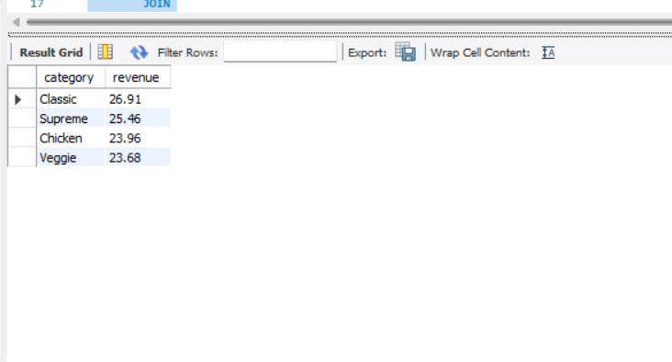

12. Analyze the cumulative revenue generated over time.

select order_date,

sum(revenue) over(order by order_date) as cum_revenue

from

(select orders.order_date, sum(order_details.quantity * pizzas.price) as revenue

from order_details join pizzas

on order_details.pizza_id = pizzas.pizza_id

join orders

on orders.order_id = order_details.order_id

group by orders.order_date) as sales;

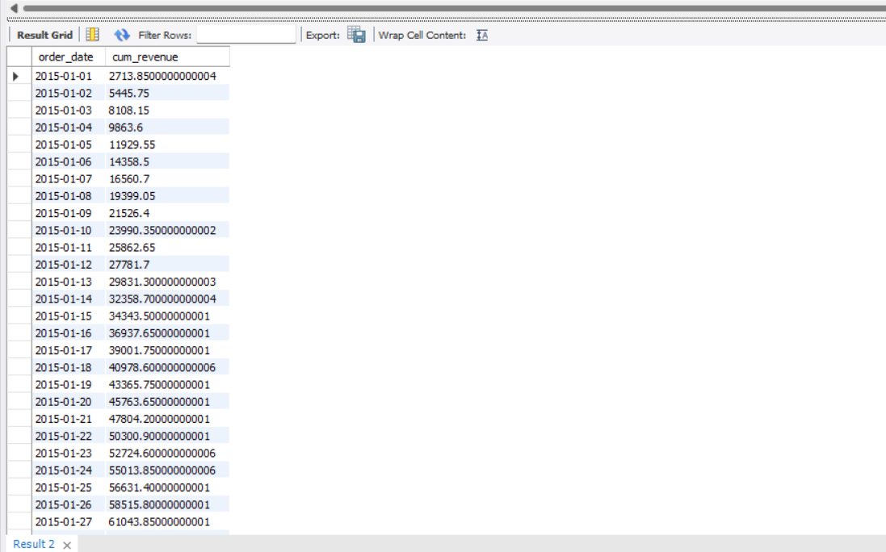

13. Determine the top 3 most ordered pizza types based on revenue for each pizza category.

select name, revenue from

(select category, name, revenue,

rank() over(partition by category order by revenue desc) as rn

from

(select pizza_types.category, pizza_types.name, SUM((order_details.quantity) * pizzas.price) AS revenue

from pizza_types join pizzas

on pizza_types.pizza_type_id = pizzas.pizza_type_id

join order_details

on order_details.pizza_id = pizzas.pizza_id

group by pizza_types.category, pizza_types.name) as a) as b

where rn <= 3;

